FAQ re: Ga Ct of Appeals Podcast Outline
Guest: Judge Rickman
Wade: Hello folks and welcome to another episode of the Good Judge-ment Podcast. I’m your host, Wade Padgett.
Tain: You guessed it - I continue to be Tain Kell.
Wade: Tain, we have an FOP back today!
Tain: That’s right, Judge Brian Rickman is back today for a second appearance on the podcast!
Wade: Last time, we talked with Presiding Judge Rickman about his work with the JQC. Today, we are going to pepper him with frequently asked questions about his day job at the Georgia Court of Appeals.
Tain: Presiding Judge Rickman – we previously recorded some episodes with other guests about “burning questions” concerning the Ga Dept of Corrections and other departments within our justice system – Today, we are going to ask you a few burning questions that our studio audience has about the Georgia Court of Appeals. Are you ready?

All kidding aside – like we could afford a studio audience – we do occasionally get asked some questions about the CoA and we thought you would be a perfect person to answer those questions from your perspective.
Let’s start with this – what is a “presiding” judge of the CoA and how is that different from just a “judge”? (15 total judges, 5 panels of 3. Presiding judge leads a panel)
Next question – what is the deal with the “terms of court”? Like how many are there and why do you care about when a term of court ends? (3 terms in a year – April, August and December - “two term rule”)
Next question – How are the five panels of judges selected? Do you get to pick which judges you serve with during a given term? Do you put like-minded judges together or keep them apart on purpose? (Chief Judge – Currently Judge Trent Brown – and we all have different backgrounds, interests, etc. I am not sure what “like minded” would mean, given the diversity of our cases)
Next question – Do you judges really read all these briefs that get filed with the court? (unfortunately, yes) Do you have a staff that helps with that? (3 staff attorneys per judge and the central staff attorneys. Plus a judicial assistant)
Next question – Do you think that oral argument is important? Why or why not? (Under what circumstances should a litigant request oral argument?)
Next question – When I am writing a brief, should I cite unreported cases or cases from other jurisdictions? (“persuasive” vs “precedent”)
Next question – How up-to-date is the online docket? (“real time” vs a day removed from filing)
Next question – What happens if I read the rules and file my appeal in the wrong appellate court? (transferred – but different if direct vs application)
Next question – Some opinions have a note that it is “physical precedent only.” What does that mean? (older rule when one judge dissented or joined opinion in “judgment only”)
Next question – Your court has a bunch of rules about how the brief should appear, what citations to the record need to be made, etc. Is all of that really important? (yes – we are not measuring margins but if you don’t cite to the record or cite precedent…)
Next question - what advice would you give to a lawyer who needs to file an appeal? (especially if the lawyer does not regularly handle appeals)
Final question – we hear that the Georgia CoA is among the busiest state appellate courts in the country. What does that actually look like – numbers, etc.? (see below)

[Stats]
Our COA is busy – particularly when you consider the “two term rule”
[following from CoA website – do not have 2025 yet]
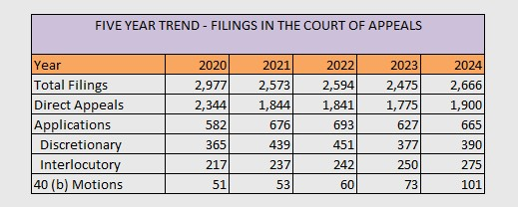
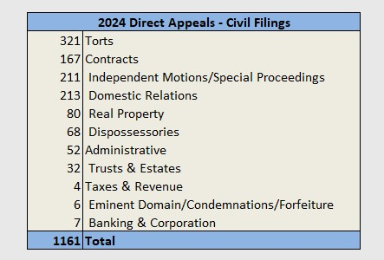

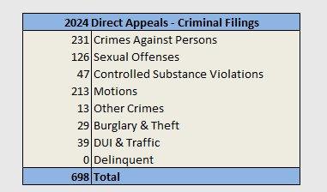
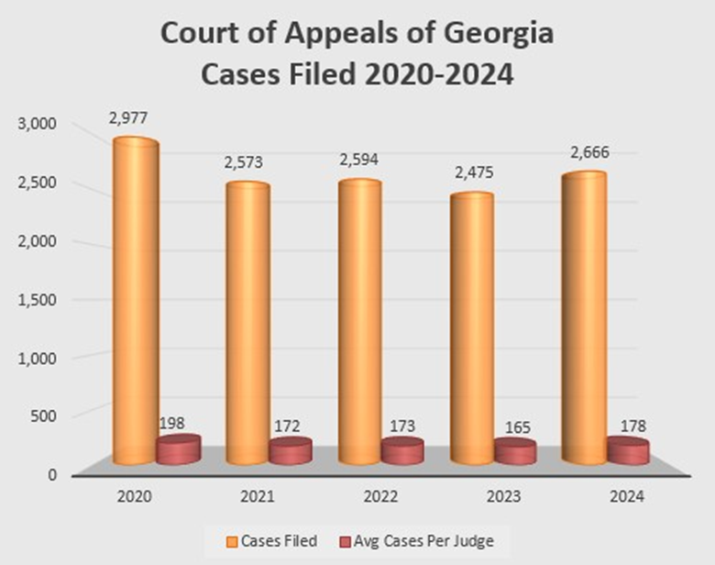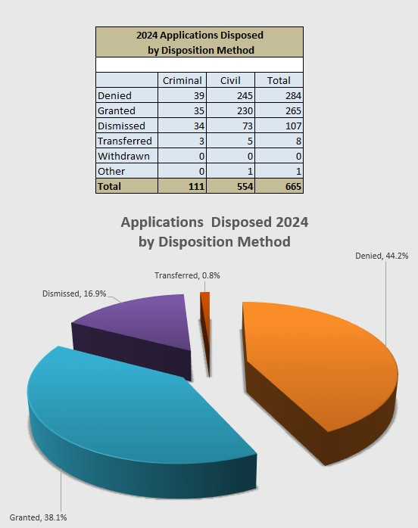

MUSIC TRIVIA (use prerecorded)

